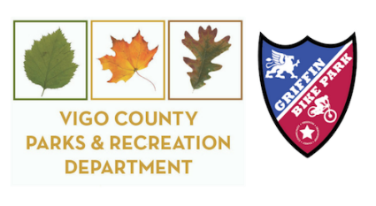
Pioneer Days - October 3 – 4, 2026
Market Vendor Information and Application
Vigo County Parks and Recreation Department is beginning to plan the 54th annual Pioneer Days, scheduled for October 3rd & 4th at Fowler Park from 10:00 a.m. to 5:00 p.m. You are invited to join us this year in the Market.

Market Vendor Information
- The Market will be located in the field south of the Irishman’s Covered Bridge.
- We encourage you to sell items that are homemade and/or handcrafted; however, other items will be permitted.
- The fee for each space is $25 per day. No more than three spaces per vendor are allowed. NO REFUNDS will be issued.
- Spaces in the Market are approximately 30 feet wide and 20 feet deep.
- No tents, tables or electricity are provided.
- If you are selling/doing anything that might result in a patron getting sick and/or harmed, you should ensure that your personal insurance covers your liability.

Parking Information
- Cars, trucks, and/or trailers will only be permitted on the grounds for loading and unloading.
- Once unloaded, you must move your vehicles to the parking lot by the Beach on the opposite side of the lake. You can then walk through the Pioneer Village to return to your market space. Please make sure you have enough items to sell for the entire day.
- Parking at Shelter A (near Market) is reserved for Food Vendors only. If you are disabled, please let us know and we will do our best to accommodate.
- You will be issued two parking passes. Additional vehicles will need to pay $5 per day and park in the visitor lot on Bono Road.

COMPLETED APPLICATION AND PAYMENT MUST BE SUBMITTED BY FRIDAY, AUGUST 29TH, 2025

Each participant will receive a reminder letter and map of your location closer to the date. If you have any questions, please contact the Vigo County Parks and Recreation Department Administration office at 812-462-3392 or email Tavia.Hedrick@vigocounty.in.gov.

Thank you!
Tavia Hedrick
Natural Resource Programmer
PLEASE KEEP THIS LETTER FOR YOUR RECORDS

Market Vendor Application
Name:
Name of Business (optional):
Mailing Address:
Phone Number:
Email Address:
Description of merchandise to be sold:
Number of market spaces:
($25 per day per space)
I will be participating on the following days:
Checks should be written to:
Vigo County Parks and Recreation Department
Completed application and payment must be submitted by
Friday, August 28th at 4:00 p.m.
All Market spaces will be available on a first-come-first-served basis.

